Experience the extraordinary riding on our areas multi-use, downhill & cross country trails. It’s a completely different way to enjoy the wilderness that we call The Ozarks.

Council Bluff Loop Trail (starting at boat launch), Ozark Trail
12mi loop, 5 out of 5 for difficulty

This loop trail follows the perimeter and shoreline of Council Bluff Lake. There are three trailheads along the loop, the Council Bluff Boat Launch, the Enough Boat Launch, and the swimming beach. This trip uses the Council Bluff Boat Launch, which has plenty of parking and is open all year (note: there is a $3/day parking fee).
This trail undulates, twists, and turns for twelve miles with only one significant climb. It's a favorite spot for mountain bikers and is a great spot for a fall morning hike. (27.3 miles from hotel)
https://www.ozarktrail.com/planner/maps/detailed/TraceCreek2.jpg

St. Joe State Park, Park Hills, MO
Hickory Ridge (4mi) & Pine Ridge Trails (12mi) offer the most challenge to mountain bikers. Terrain includes riding through woods, streams, dried creek beds, etc, and range from flat to more than a 10% incline. There is also a paved trail through the park for those looking for a more comfortable ride. (16 miles from hotel.)

https://mostateparks.com/page/89816/st-joe-state-park-trails
Council Bluff Boat Launch to Highway A Trailhead, Ozark Trail
13.3mi, point to point, 3 out of 5 for difficulty

This trip covers the southern part of the Trace Creek section starting out at the Council Bluff Lake area. Some consider the Southern Trace a better ride than the Northern Trace.

This is a great way to experience the southern part of the Trace Creek section of the Ozark Trail. By utilizing the boat launch parking at Council Bluff Lake, you get a nice ride/hike along the water before heading over to the Trace Creek section. (Of course, you can do the trip in the opposite direction and end along the lake. Shuttle schedules and personal preference will help you decide.)
Watch for intersections and consult your map and trip itinerary to make the right turns. Ottery Creek by the Highway A trailhead is often a 'wet crossing' with typical depths of 8'-16' (Do not attempt immediately after heavy rains due to possible flash flooding)
(27.3 miles from hotel)
https://www.ozarktrail.com/planner/maps/detailed/TraceCreek2.jpg
https://www.ozarktrail.com/planner/maps/detailed/TraceCreek3.jpg

Full Marble Creek Section of the Ozark Trail
9.6 miles point to point, 3 out of 5 for difficulty

Follow the Marble Creek section of the Ozark Trail from the campground, to the opposite end of Crane Lake. You can add more miles to your day by riding the loop around the lake. (Campground: 17 miles from hotel)
https://www.ozarktrail.com/planner/maps/detailed/MarbleCreek1.jpg

Crane Lake Loop, Ozark Trail
4.7 miles, 3 out of 5 for difficulty

A great ride in the wilderness around this man-made lake. 4.7 miles of beautiful scenery…but don’t let this short ride fool you…it’s not for the faint of heart. The first half features areas of intense rocky climbs that will challenge even the most skilled riders. If you want to cut it short you can take the trail just past the dam, downhill and carry your bike over the shut-ins to the other side while enjoying the sound of the rushing water. Stop for a view of the lake before traveling the gravel road back to the start. Or, follow the creek to the water crossing, returning by the dam and gravel road.
An alternative, and easier ride, is to ride the gravel to the dam, hit the trail there, follow the creek, then return the way you came. (15.1 miles from hotel)
https://www.ozarktrail.com/planner/maps/detailed/MarbleCreek1.jpg

Shepherd Mountain Bike Park
Boasting of some of the best downhill trails to challenge any skill level, SMBP also has a great climb trail, with plans for cross country trails in the works. Do you have what it takes to make it up 2.3mi & 650’+ gain of elevation on Coolios Climb? If you do, you’ll be rewarded by your choice of downhill trails on the way back. (There is also a “steep” & “less steep” trail you can take straight to the top of SM which is shorter than 2.3mi… but it’s still 650’ elevation gain. Ride to the top on Less Steep in record time to earn the title of King/Queen of the Mountain!)

Of course, you can skip the manual climb and purchase lift tickets (available on the weekends) at the Wheel House and enjoy gravity all day.
(0.5 miles from hotel)
https://shepherdmountainmo.com/

Johnson Shut-In’s
Not a MTB trail, but the Black River Trail is a 3.1mi, hard surface bike path connecting the campground to the day use, Shut-In’s area & interpretative center. Hike, bike, play in the water, & enjoy all the amazing rock formations. (15.6 miles from hotel)
https://mostateparks.com/sites/mostateparks/files/TrailDetails-BlackRiverTrailSystem.pdf

North Middle Fork with part of the Council Bluff Trail
17.7mi point to point, 4 out of 5 difficulty

A very good ride that extends the north-half of the Middle Fork with pieces of the Trace Creek and Council Bluff Trails.

An excellent trip in either direction, this route runs from the Council Bluff Boat Launch to Barton Fen. You'll get a great section of the Middle Fork Trail plus a bit of the Council Bluff Loop, with a section of the south Trace Creek in between. There are several intersections to navigate, so bring a map and a printed itinerary to stay on course.
This trip features lakeside views, long flowing downhills, gurgling brooks, and a waterfall. There's lots of pines along the way, too! A thrilling trip worthy of 4-5 stars.
On the south end please use the gravel road, since the trail on the west side of Barton Fen is designated for foot-only traffic. (Barton Fen: 31.9 miles from hotel, Council Bluff: 27.3 miles from hotel)
https://www.ozarktrail.com/planner/maps/detailed/TraceCreek2.jpg
https://www.ozarktrail.com/planner/maps/detailed/MiddleFork1.jpg

Trace Creek Section
13.2mi point to point, 3 out of 5 difficulty

(Hazel Creek Trailhead: 29.2 miles from hotel, North DD Trailhead: 26 miles from hotel)
https://www.ozarktrail.com/planner/maps/detailed/TraceCreek1.jpg
https://www.ozarktrail.com/planner/maps/detailed/TraceCreek2.jpg

Welcome to the Arcadia Valley. The word “Arcadia” comes from the Greek, meaning a scene of simple pleasure and quiet. As you travel throughout our valley, you will agree the name fits perfectly.
You are our guest and we cordially invite you to share with us the Arcadia Valley’s unsurpassed beauty and heritage.
Fort Davidson Hotel sincerely hopes your stay with us will be a pleasant one. Have fun and come back soon.

For more information on the many scenic, historic, and recreation sites in the valley,
call Fort Davidson Hotel at
573-546-7427
or visit us on the web at www.fortdavidson.com

Mountain Bike/
Multi-use Paths
of the
Ozark Trail
&
Surrounding Areas

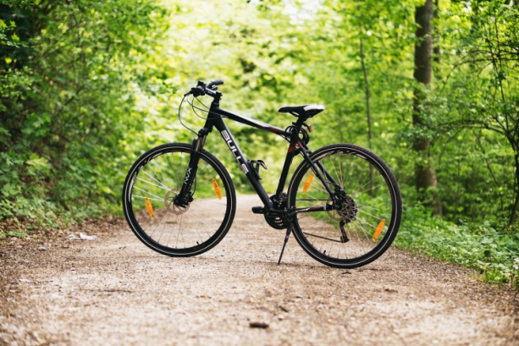

ROADS
NOT
REQUIRED

Complements of Fort Davidson Hotel
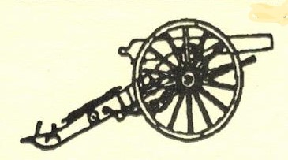www.fortdavidson.com

